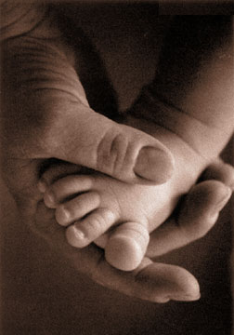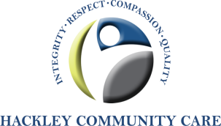

***Are you Pregnant or did you just have a baby?***

***Have you experienced any of the following or more?***

***►Mood Changes ►Difficulty Sleeping***

***►Depression ►Worry and Anxiety***

***►Crying and Feeling Sad ►Feeling Overwhelmed***

***You are not alone.***

**Hackley Community Care is offering a free Postpartum Support Group**

**for pregnant and/or new mothers.**

**Qualified Postpartum Depression Specialist will facilitate the support group.**

**Postpartum**

**Support Group**

**Support Groups: 1st and 3rd Wednesday of the month**

**from 1:00pm to 2:30pm**

**Location: First Presbyterian Church**

**2577 Wickham**

**Muskegon, MI 49441**

**(Corner of Sherman and Wickham, across from Sherman Bowling Lanes)**

**For more information Call 231-733-6786**

**Walk-ins are welcome.**

**You may bring your Baby and support person too.**

The Hackley Community Care Postpartum Support Group is made possible in part through

a grant from the Great Start Collaborative of Muskegon County.