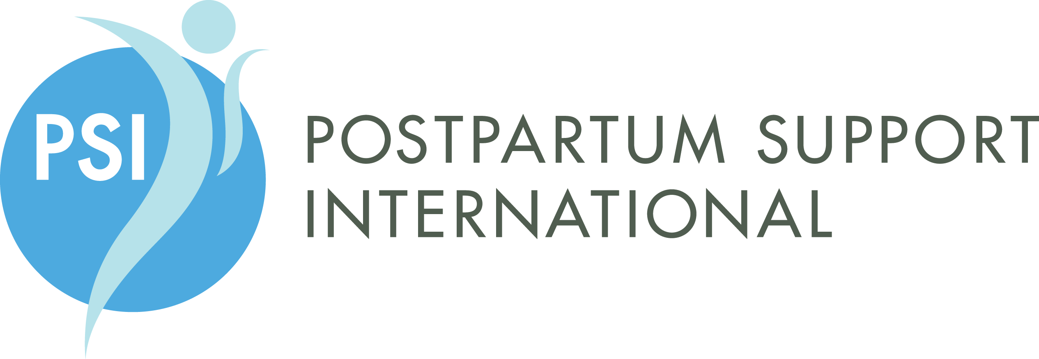

29th Annual Postpartum Support International Conference in San Diego California
Bridging, Bonding, and Beyond: Clinical Expertise and Community Outreach
June 22-25, 2016

We are happy to announce the request for speaker proposals for the 29th Annual Postpartum Support International (PSI) Conference in San Diego California. The 2016 Conference theme is Bridging, Bonding, and Beyond: Clinical Expertise and Community Outreach in Perinatal Mental Health. The conference will be held in beautiful San Diego, California on June 24-25, 2016. On June 22-23, we will hold our annual 2-day pre-conference PSI Perinatal Mood and Anxiety Disorders Certificate Course.

The annual PSI conference provides an opportunity to meet, learn together, and share ideas with others involved in the field of perinatal mood and anxiety disorders (PMADs). This professional event is a unique training and networking opportunity, attracting more than 200 participants. The purpose of the conference is to bring together and inform medical and mental health providers, childbirth professionals, support and resource providers, caregivers, policy-makers, researchers, volunteers, families, and educators who want to improve their understanding of PMADs and improve their ability to serve pregnant, postpartum, and post pregnancy-loss families.

We are accepting proposals for the main conference on June 24-25, 2016. Because of the professional diversity of PSI membership and conference attendees, we welcome presentations with scientific data as well as those addressing clinical expertise or community projects. Conference workshops will include topics relevant to: psychopharmacology; psychobiology; psychotherapy; community systems, advocacy and development; diversity and culturally-informed services; integrated systems of behavioral and primary care; fathers, families, and partners; complementary medicine; innovation in solutions; peer support and community networks.

Presentations will be between 60 and 90 minutes long; the Program Selection Committee will decide on the length of presentation once all proposals are reviewed. We welcome both didactic and experiential proposals, as well as poster presentations. Please note that most attendees have a basic understanding of perinatal mental health and are eager to learn about advanced clinical skills, innovative community programs, and current research.

Proposals are due by December 1, 2015 and should be sent by email to psioffice@postpartum.net or by fax to 503-894-9452. An email acknowledgement from the PSI office will be confirmation that your proposal has been received. If you don’t receive an acknowledgment, please contact the office at 503-894-9453 or psioffice@postpartum.net. Proposal acceptance letters will go out by December 20, 2015.

We are eager to hear your ideas!

2016 PSI Conference Selection Committee
Postpartum Support International www.postpartum.net

In collaboration with Strategies Center at Youth for Change
Submission Format Requirements for Presentation Proposals
Proposals Due by December 1, 2015

Title of Presentation: Provide title as it might appear in conference program. Please limit to 10 words or less.

Presenter Name(s) and any Degrees as you wish it to appear in program:

Presenter(s) Contact (list all presenters):
Email:
Telephone:
Street Address:

Presenter Bio(s) – list all presenters: Please limit to 75 words each

Proposed Format? e.g., Workshop; Poster, Panel Presentation:

Title and Description: Title, and a brief 24 -30 word description of the presentation content. Describe the session in a way that might be used in a conference brochure.

Behavioral Objectives: Provide three to five measurable objectives that describe, in behavioral terms, the knowledge, skills, or learning outcomes that complete the sentence, e.g.: "At the conclusion of this presentation, participants will be able to _______” (Use active terms such as: describe, list, discuss, identify).

Topic/Content Outline: (poster presentations can abbreviate this section). Include the proposed presentation content in Roman Numeral outline format. The content outline should directly relate to and support the learning objectives. Label each outline section with the objective it supports. Include the number of minutes you plan to spend on each outline section. Sessions will be between 60 or 90 minutes long, to be decided by the Program Committee.

Teaching Methods and Strategies for Adult Learning: List the methods, teacher/learning strategies, materials and resources to be used by speaker to cover each objective. Teaching methods include but are not limited to: lecture, panel discussion, role play, Q& A, demonstrations, practice, specific audiovisuals, etc.

References or Bibliography: List References and/or bibliography to support your proposal.

Attachments: Please attach the following to your application: current resume or CV; high quality digital photo.

Poster Presentations Submissions
Poster Submissions are being accepted for poster presentations of completed research, research in progress, new program design and implementation, or poster descriptions of state or regional projects and initiatives.

The Selection Committee might recommend that some proposals be submitted in poster format, or be combined with other selected presenters.

Registration: There is no honorarium for presenters, but you will be able to register for the conference at no charge on the day you present. Up to 3 panelists for a group presentation can register at no charge of day of presentation.

Susan A Hickman Research Award: If you are a researcher, we’d like to invite you to apply for the Hickman research award. Please visit the link to learn about submitting an application for the 2016 award. http://www.postpartum.net/professionals/susan-a-hickman-research-award/

Please send all materials to psioffice@postpartum.net or fax to 503-894-9452, and contact us there with any questions. Primary presenters are responsible for conveying this and all subsequent conference-related information to any co-presenters.

Primary submitters of presentations will be notified via email regarding acceptance by December 20, 2015.

You will receive an email confirmation from the PSI Office after we receive your proposal; please contact psioffice@postpartum.net if you do not receive that acknowledgement.

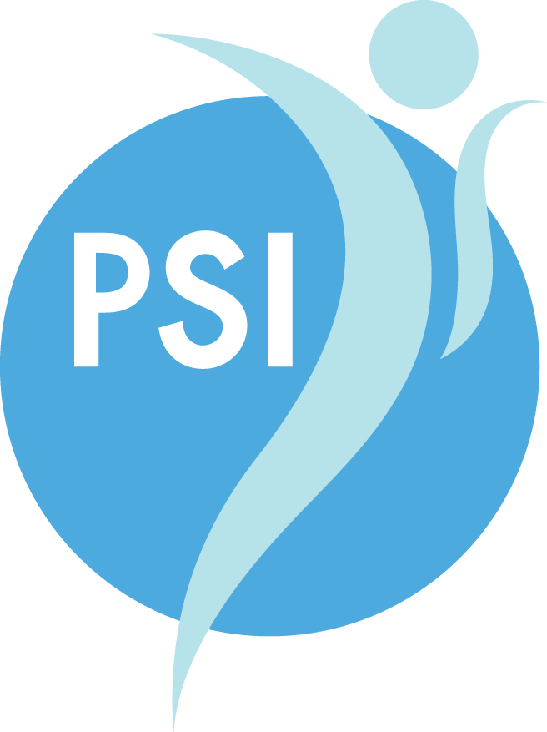

Are you already a member of PSI?
You can learn more about joining or renewing your PSI membership and receive member benefits such as membership in our active professional and Reproductive Psychiatry Listserves, discounts on products and trainings, and access to our members directory on the website.
www.postpartum.net/join-us/become-a-member/

Access our worldwide support network
www.postpartum.net/locations

