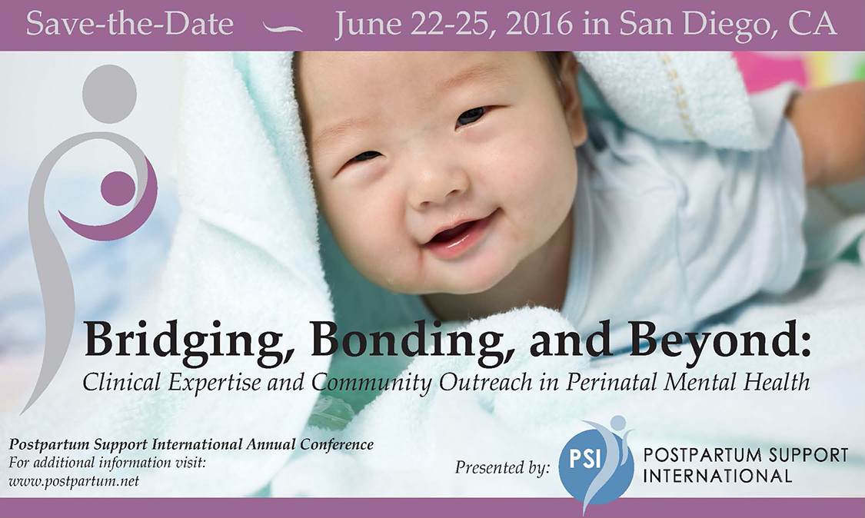
Postpartum Support International
29th Annual Conference
June 22-25, 2016
Mission Valley Hilton, San Diego CA

SPONSORSHIP INFORMATION

The annual PSI conference is a unique international training and networking opportunity, attracting more than 300 participants. The conference brings together medical and mental health providers, childbirth professionals, support and resource providers, caregivers, policy-makers, researchers, volunteers, families, and educators to improve their understanding of PMADs and their ability to serve pregnant, postpartum, and post pregnancy-loss families.

Conference workshops include a range of divers topics, including psychopharmacology; psychobiology; psychotherapy; community systems, advocacy and development; diversity and culturally-informed services; integrated systems of behavioral and primary care; fathers, families, and partners; complementary medicine; innovation in solutions; peer support and community networks. With our pre-conference certificate training, 28 breakout workshops, four expert keynotes, and a banquet gala, our conference always leave informed and inspired.

We invite you to join us in this valuable undertaking by becoming a conference sponsor or exhibitor. Your Sponsorships enable us to offer scholarships, train volunteers and providers, continue our telephone support line in English and Spanish, translate materials for families, and provide direct family services and educational outreach. Becoming a sponsor of this event brings you a unique opportunity to highlight your organization while supporting families and the health care community that serves them.

2016 Keynote Presenters:
- Vivien Burt, MD - Dr Burt is a leading expert in Reproductive psychiatry and women’s mental health, a Professor of Psychiatry in the Department of Psychiatry and Biobehavioral Sciences at the David Geffen School of Medicine at UCLA, and Founder and Director of The Women’s Life Center of the Resnick UCLA Neuropsychiatric Hospital.
- Vincent Felitti, MD, co-Principal Investigator of the Adverse Childhood Experiences (ACE) Study, ongoing collaborative research between the Kaiser Permanente Medical Care Program and the Centers for Disease Control. Founder of the Department of Preventive Medicine for Kaiser Permanente, Felitti served as the chief of preventive medicine for over 25 years. Dr. Felitti is Clinical Professor of Medicine at the University of California and a Fellow of The American College of Physicians.
- Danny Singley, PhD and David Levine, MD, Father’s Perinatal Mental Health Panel: David Levine is an adolescent clinic preceptor for the Atlantic Health System Internal Medicine Residency Program, and has been featured in the New Jersey Family "New Jersey's Favorite Kids' Docs." He was featured on the Charlie Rose show, discussing his own experience with paternal postpartum mental health. Dr Singley is a San Diego-based board certified psychologist and Director of The Center for Men’s Excellence. His research and practice focus on men’s mental health with a particular emphasis on reproductive psychology and the transition to fatherhood.
- Sherry Payne, MSN, RN, CNE, IBCLC, presents nationally on topics related to perinatal health disparities, infant mortality, and lactation professions. She is a master’s prepared nurse educator, and lactation consultant. Ms. Payne is the Executive Director of Uzazi Village, a nonprofit organization devoted to decreasing pregnancy related health disparities in the urban core of Kansas City. She is the creator of the Sister Doula Program TM and the Chocolate Milk Cafe TM.
Sponsorship Levels and Opportunities
Deadline for Inclusion: May 20, 2016

Find more information about the 2016 PSI Conference at this link.
www.postpartum.net/professionals/psi-annual-conference-2016/
$2000 – Gold Level Sponsor
Four (4) comp tickets to Friday banquet
Recognition in Conference printed materials
Exhibitor table at Conference for 2 days
Recognition in Newsletters
Recognition on Websites Logo in Conference Program & ¼ page ad
Post-event publicity in newsletters, websites

$1500 – Silver Level Sponsor
Two (2) comp tickets to Friday banquet
Exhibitor table at Conference for 2 days
Recognition in Newsletters
Recognition on Websites
Recognition in Conference Program & 1/8 page ad

$1000 – Bronze Level Sponsor
One (1) Comp Ticket to Friday banquet
Exhibitor table at Conference for 2 days
Recognition on PSI & Tree of Hope Websites
Recognition on Conference Program

$10,000 - Presenting Sponsor
Verbal recognition at Opening and Keynote addresses
Special Recognition in Conference press release
Logo on Conference printed materials
Exhibitor table at Conference for 4 days
Four (4) complimentary admissions to Conference
Four (4) Comp Tickets to Friday night banquet
Recognition in PSI Newsletters
Logo with hyperlink on Websites
Logo in Conference Program & one page ad
Post-event publicity in newsletters, website and other news

$5000 – Diamond Sponsor
Verbal recognition prior to Conference Keynote address
Logo on Conference printed materials
Exhibitor table at Conference for 4 days
Two (2) complimentary admissions to Conference
Four (4) Comp Tickets to Friday night banquet
Recognition in PSI Newsletters
Logo with hyperlink on Websites
Logo in Conference Program & one page ad
Post-event publicity in newsletters, website and other news

$3000 – Platinum Sponsor
Verbal recognition prior to Conference Keynote address
Recognition in Conference printed materials
Exhibitor table at Conference for 4 days
One (1) Complimentary admission to Conference
Two (2) Comp Tickets to Friday night banquet
Recognition in Newsletters and Websites
Logo in Conference Program & 1/2 page ad
Post-event publicity in newsletters, website and other news
Exhibitor Opportunities and a la carte
$500 – Business Friend  (sponsor or exhibitor)  Exhibitor Table / all 4 days  (Daily table rate $150)  $350 – Non Profit/Government  (sponsor or exhibitor)  Exhibitor table / all 4 days  (Daily table rate $100) | $250 – Advertising in Program  Quarter page company advertisement in Conference program  $150 – Item in Conference Bag  Add your company branded item or informational materials to the conference bag

SPONSORSHIP or EXHIBITOR AGREEMENT
Postpartum Support International 2016 Annual Conference
Mission Valley Hilton | San Diego CA

SPONSORSHIP/EXHIBITOR |  | Amount
 | Presenting Sponsor | $10,000
 | Diamond Sponsor | $5000
 | Platinum Sponsor | $3000
 | Gold Sponsor | $2000
 | Silver Sponsor | $1500
 | Bronze Sponsor | $1000
 | Business Exhibitor | $500 four days  Single days $150/day
 | Non Profit Exhibitor | $350 four days  Single days $100/day
 | Program Ad | $250
 | Item in Conference Bag | $150
Organization
Your Name
Address
Suite
City
State _____________ Zip
Phone Number
Fax number
E-mail
Business Type (check one):
☐ Community Service Organization
☐ Non-Profit Organization
☐ Business/For Profit
☐ Governmental Agency
☐ Individual (not business)
Please describe your business:

If you have selected to be a conference sponsor, or are purchasing exhibitor space, please check which days you will have a table (check at least one or all that apply):
☐ WED, June 22: Pre-conference PSI Certificate Training
☐ THURS, June 23: Pre-conference PSI Certificate Training, PSI Volunteers/Board Meeting
☐ FRIDAY, June 24: Main Conference Day 1
☐ SATURDAY June 25: Main Conference Day 2

Will you have a representative at the event in San Diego? If yes, please write full name(s) and dates

Please return this completed form to psioffice@postpartum.net, or fax or mail below. Call us if you’d like to pay by credit card, or send a check with memo to:

Postpartum Support International • 6706 SW 54th Avenue • Portland OR 97219
Phone: 503-894-9453 • Fax: 503-894-9452

