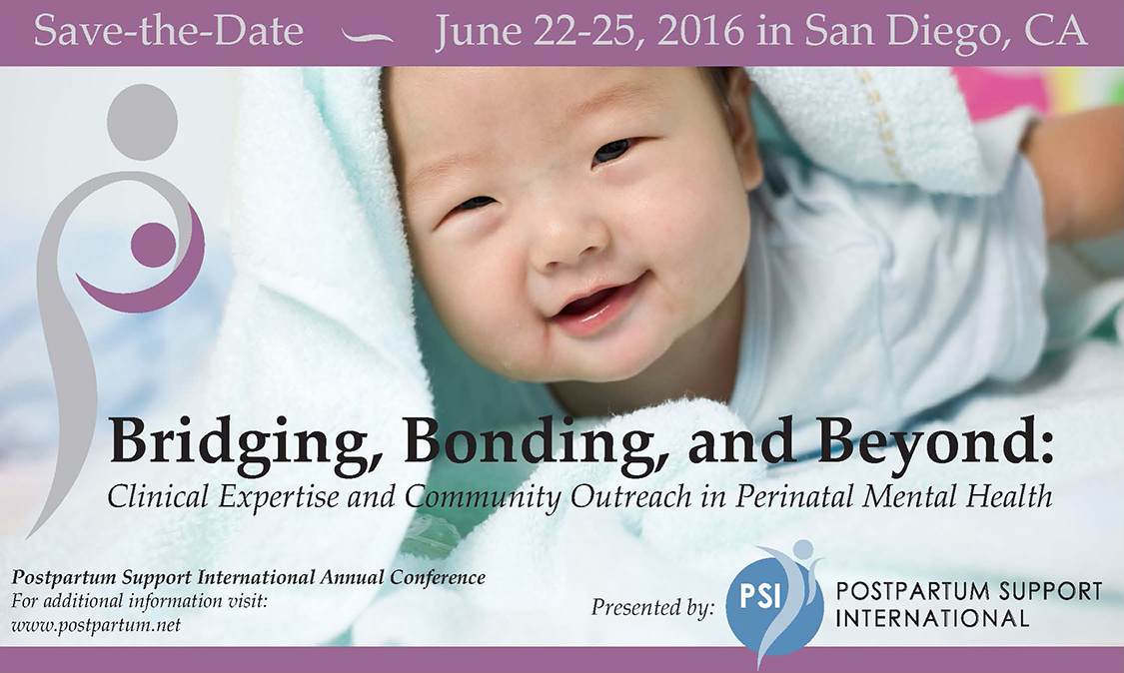
Postpartum Support International
29th Annual Conference
June 22-25, 2016
Hilton San Diego Mission Valley
San Diego, California

PSI 2016 CONFERENCE EXHIBITOR INFORMATION
The annual Postpartum Support International (PSI) conference is a unique international training and networking opportunity, attracting more than two hundred participants. The conference brings together medical and mental health providers, childbirth professionals, support and resource providers, caregivers, policy-makers, researchers, volunteers, families, and educators to improve their understanding of perinatal mood and anxiety disorders (PMADs) and their ability to serve pregnant, postpartum, and post pregnancy-loss families.

Conference workshops include a range of topics, including psychopharmacology; psychobiology; psychotherapy; community systems, advocacy and development; diversity and culturally-informed services; integrated systems of behavioral and primary care; fathers, families, and partners; complementary medicine; innovation in solutions; and peer support and community networks. With our pre-conference certificate training, twenty-eight breakout workshops, a poster session, four expert keynotes, and a banquet gala, our conference attendees always leave informed and inspired.

We invite you to join us in this valuable undertaking by becoming a conference exhibitor. Becoming an exhibitor of this event brings you a unique opportunity to highlight your organization while supporting families and the health care community that serves them.

2016 Keynote Presenters:
- Vivien Burt, MD, is a leading expert in reproductive psychiatry and women’s mental health, a Professor of Psychiatry in the Department of Psychiatry and Biobehavioral Sciences at the David Geffen School of Medicine at UCLA, and Founder and Director of The Women’s Life Center of the Resnick UCLA Neuropsychiatric Hospital.
- Vincent Felitti, MD, the Adverse Childhood Experiences (ACE) Study, ongoing collaborative research between the Kaiser Permanente Medical Care Program and the CDC. The ACE Study with its more than sixty publications explores prospectively and retrospectively in a 17,000-person cohort the profound relationship of ten categories of adverse life experiences in childhood to health, well-being, disease, and death decades later. Dr Felitti is the founder of the Department of Preventive Medicine for Kaiser Permanente, and served as the chief of preventive medicine for over twenty-five years. He is Clinical Professor of Medicine at the University of California and a Fellow of The American College of Physicians. Presently, he is a member of the Advisory Committee on Women’s Services at SAMHSA.
- David Levine, MD, appearing on the Father’s Perinatal Mental Health Panel, is an adolescent clinic preceptor for the Atlantic Health System Internal Medicine Residency Program, and was featured in the New Jersey Family magazine’s "New Jersey's Favorite Kids' Docs", as well as the Charlie Rose show, discussing his own experience with paternal postpartum mental health.
- Danny Singley, PhD, also appearing on the Father’s Perinatal Mental Health Panel, is a San Diego-based board certified psychologist and Director of The Center for Men’s Excellence. His research and practice focus on men’s mental health with a particular emphasis on reproductive psychology and the transition to fatherhood.
- Sherry Payne, MSN, RN, CNE, IBCLC, presents nationally on topics related to perinatal health disparities, infant mortality, and lactation professions. She is a master’s prepared nurse educator, and lactation consultant. Ms. Payne is the Executive Director of Uzazi Village, a nonprofit organization devoted to decreasing pregnancy related health disparities in the urban core of Kansas City. She is the creator of the Sister Doula Program TM and the Chocolate Milk Cafe TM.
SPONSORSHIP or EXHIBITOR COMMITMENT
Postpartum Support International 2016 Annual Conference
Deadline for Inclusion: May 20, 2016
Hilton San Diego Mission Valley | San Diego, California
SPONSORSHIP/EXHIBITOR |  | Amount
 | Business Exhibitor | $500 four days  Single days $150/day
 | Non Profit Exhibitor or Governmental Agency | $350 four days  Single days $100/day
 | Program Ad | $250
 | Item in Conference Bag | $150
Organization
Your Name
Address
Suite
City
State _____________ Zip
Phone Number
Fax number
E-mail
Business Type (check one):
☐ Community Service Organization
☐ Non-Profit Organization
☐ Business/For Profit
☐ Governmental Agency
☐ Individual (not business)

Please describe your business:

Please check which days you will have a table (check at least one or all that apply):
☐ WEDNESDAY, June 22: Pre-conference PSI Certificate Training
☐ THURSDAY, June 23: Pre-conference PSI Certificate Training, PSI Volunteers/Board Meeting
☐ FRIDAY, June 24: Main Conference Day 1
☐ SATURDAY, June 25: Main Conference Day 2

How many representatives will you have at the conference:

Please return this completed form to psioffice@postpartum.net, or fax or mail below.
Call us if you’d like to pay by credit card or send a check with memo to:
Postpartum Support International • 6706 SW 54th Avenue • Portland OR 97219
Phone: (503) 894-9453 • Fax: (503) 894-9452

