Parents as Teachers  The nation’s largest evidence based home visiting program.  We use curriculum to deliver free services through parent educators to all families and children prenatally through age five. PAT helps parents understand their role in encouraging their child’s development right from birth, which prepares children for school and life success. Contact us for more information.  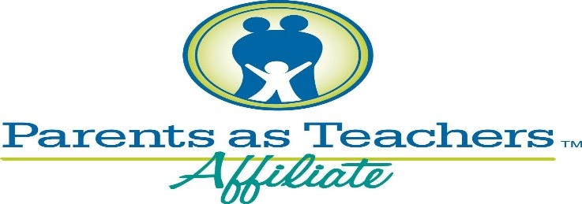 | Parenting is hard. We can help!  ────  Let’s build on your strengths.  ────  Make connections between behaviors and development!  ────  No cost, no income requirement.  ────  Free book and activity at every visit!  ────  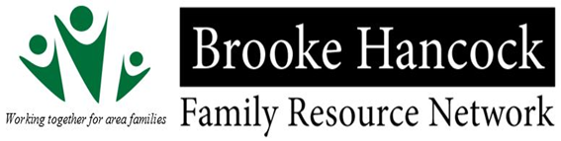  Get connected with resources, events, and more.  1300 Potomac Ave. Upper level  Weirton, WV 26062  (304)748-7850  Brookehancockfrn.org

